**DESIGN AND ANALYSIS OF HORN ANTENNA SYSTEMS**

Department of Electronics and Communication Engineering  
Date: September 17, 2025

**EXECUTIVE SUMMARY**

This report presents a comprehensive analysis of **horn antenna** systems, covering fundamental design principles, various configurations, and directional radiation characteristics. Horn antennas achieve **moderate to high directional gain** (10-25 dBi) with excellent bandwidth characteristics (10:1 to 20:1) through their flaring waveguide structure. The analysis demonstrates that horn antennas provide superior performance for microwave applications, serving as feed elements for parabolic reflectors, radar systems, and calibration standards with wide frequency operation from 300 MHz to beyond 100 GHz.

**1. INTRODUCTION**

**1.1 Background**

The **horn antenna** consists of a flaring metal waveguide shaped like a horn to direct radio waves in a focused beam. One of the first horn antennas was constructed in 1897 by Bengali-Indian radio researcher Jagadish Chandra Bose in his pioneering experiments with microwaves, while the modern horn antenna was invented independently in 1938 by Wilmer Barrow and G. C. Southworth.[1]

**1.2 Operating Principles**

Horn antennas operate by **gradually transitioning** from a confined waveguide mode to free-space radiation. The flaring structure provides impedance matching between the waveguide and free space while controlling the radiation pattern through aperture field distribution.

**1.3 Key Advantages**

Horn antennas offer **moderate directivity, broad bandwidth, low losses, and simple construction**. Since they have no resonant elements, they can operate over wide frequency ranges with usable bandwidth typically of 10:1 and up to 20:1 (allowing operation from 1 GHz to 20 GHz).[1]

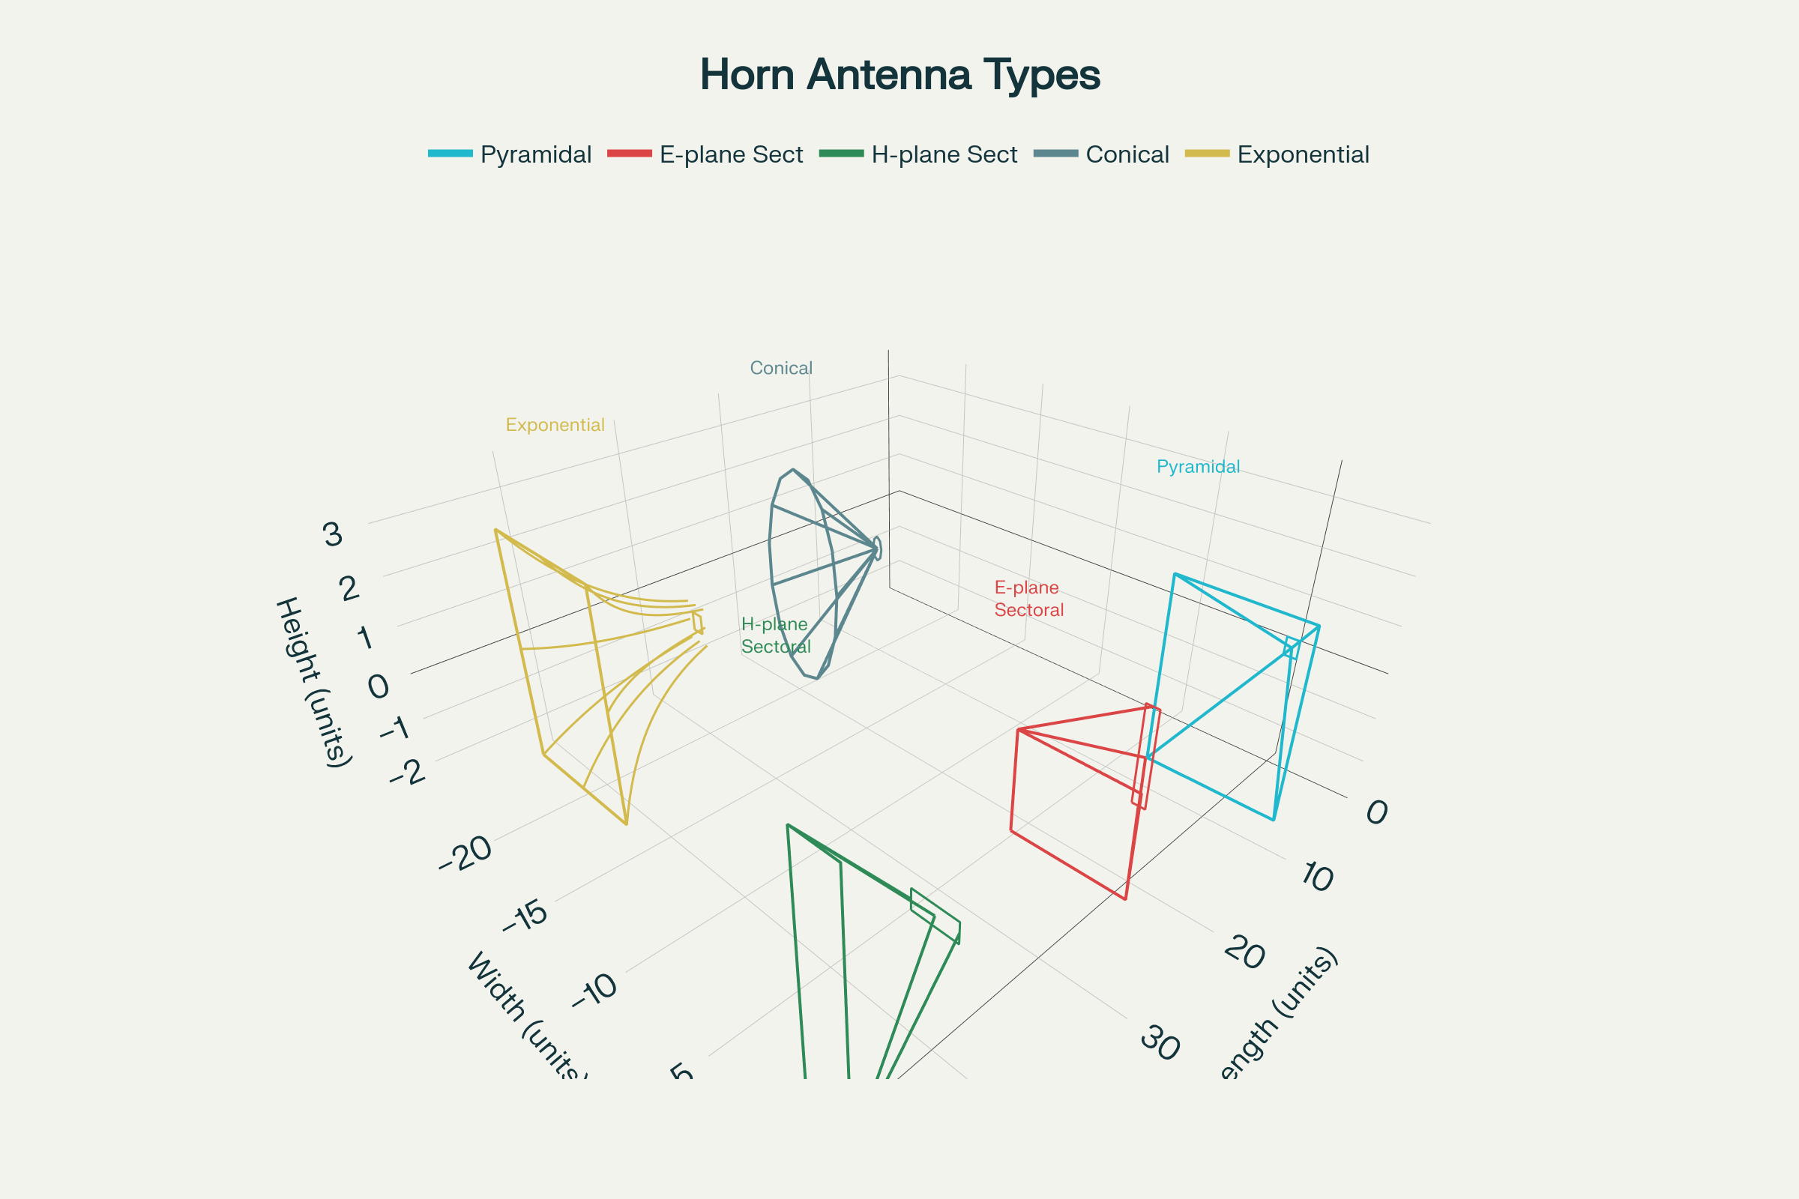

Figure 1 – Five major horn antenna types showing structural differences and configurations.

**2. FUNDAMENTAL THEORY**

**2.1 Wave Propagation**

The **waves travel down a horn as spherical wavefronts**, with their origin at the apex of the horn - a point called the phase center. The pattern of electric and magnetic fields at the aperture plane determines the radiation pattern as a scaled-up reproduction of the waveguide fields.[1]

**2.2 Phase Error Effects**

The **spherical wavefronts create phase differences** between the center and edges of the aperture, called phase error. This phase error increases with flare angle and reduces gain while increasing beamwidth, giving horns wider beamwidths than similar-sized plane-wave antennas like parabolic dishes.[1]

**2.3 Aperture Limitations**

The **increasing phase error limits practical horn apertures** to about 15 wavelengths, as larger apertures would require impractically long horns. This limits the gain of practical horns to about 1000 (30 dBi) with minimum beamwidths of 5-10°.[1]

**3. HORN ANTENNA TYPES**

**3.1 Pyramidal Horn**

The **pyramidal horn** features a four-sided pyramid shape with rectangular cross-section, commonly used with rectangular waveguides to radiate linearly polarized waves. This is the most common type, resembling a rectangular or square pyramidal structure ending in a waveguide port.[1][2]

**3.2 Sectoral Horns**

**Sectoral horns** have only one pair of sides flared while the other pair remains parallel, producing fan-shaped beams. Two variants exist:[1]

* **E-plane horn**: Flared in the direction of the electric field
* **H-plane horn**: Flared in the direction of the magnetic field

**3.3 Conical Horn**

**Conical horns** feature cone shapes with circular cross-sections, used with cylindrical waveguides. These are frequently circular or elliptical cones ending in circular or elliptical waveguides.[1][2]

**3.4 Exponential Horn**

**Exponential horns** have curved sides where separation increases exponentially with length. Also called scalar horns, they minimize internal reflections and maintain almost constant impedance across wide frequency ranges, making them ideal for high-performance applications.[1][2]

**3.5 Corrugated Horn**

**Corrugated horns** feature sidewalls with slots or grooves on the inside surface, providing very low cross-polarization and symmetric radiation patterns. The corrugated horn invented by Kay in 1962 has become widely used as feed horns for satellite dishes and radio telescopes.[1][2]

**4. RADIATION CHARACTERISTICS**

**4.1 Pattern Properties**

Horn antennas produce **highly directional patterns** with narrow main lobes and good front-to-back ratios. The radiation pattern depends on horn type, flare angle, and aperture dimensions.

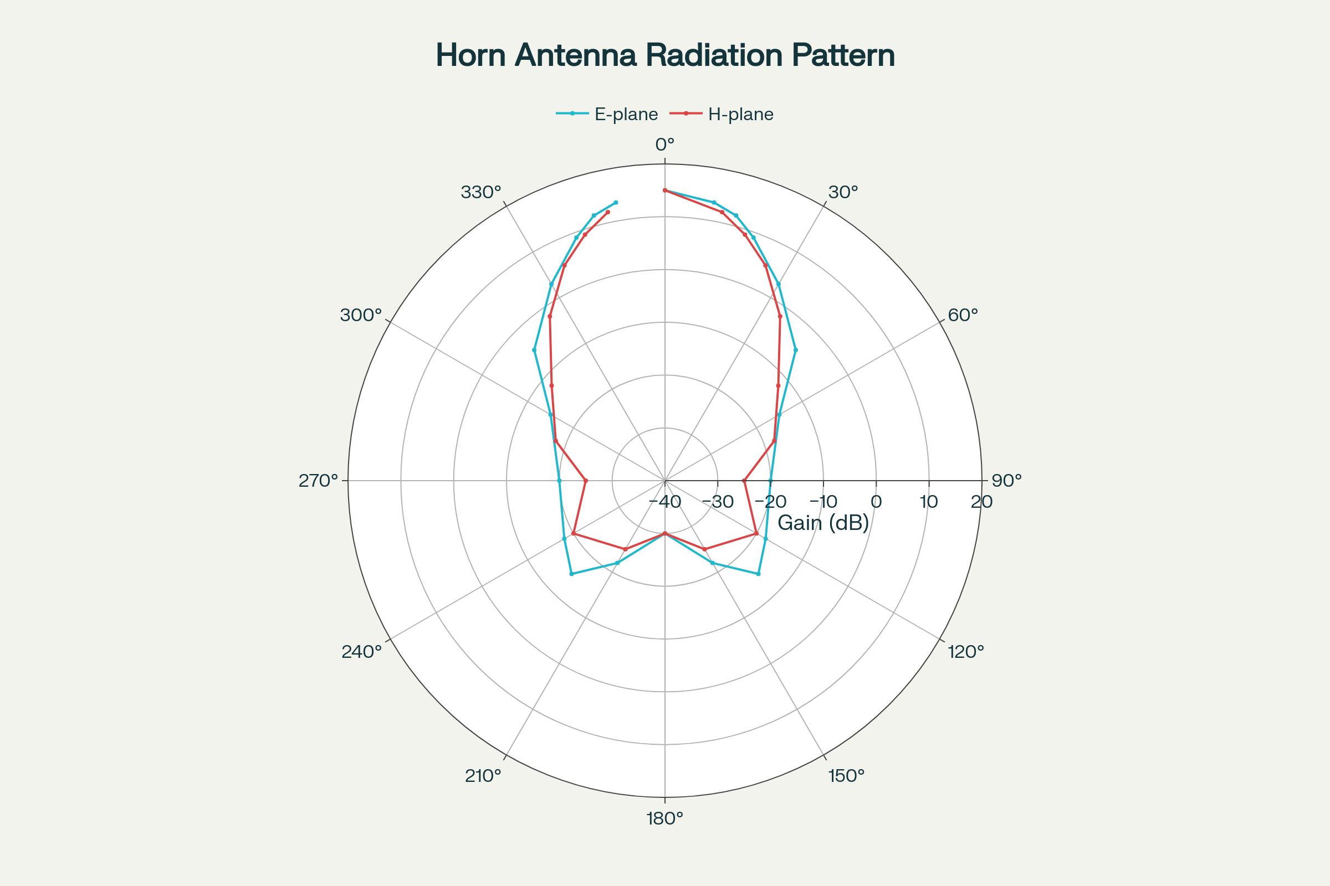

Figure 2 – Polar radiation patterns for pyramidal horn antenna showing E-plane and H-plane characteristics.

**4.2 Gain Performance**

The **gain of horn antennas ranges up to 25 dBi**, with 10-20 dBi being typical. Pyramidal horns achieve maximum radiation that may not be directed exactly along the axis due to phase error effects.[1][3]

**4.3 Beamwidth Characteristics**

**Beamwidth decreases with increasing aperture size**, but longer horns are required to maintain narrow beams due to phase error constraints. The flare angle determines the balance between gain and beamwidth.

**5. DESIGN METHODOLOGY**

**5.1 Dimensional Calculations**

**Pyramidal horn design** requires careful calculation of flare angles and aperture dimensions. The physical construction requires that pe and ph dimensions be equal for optimal performance.[3]

**5.2 Impedance Matching**

The **gradual transition from waveguide to free space** provides excellent impedance matching. Input impedance varies slowly over wide frequency ranges, allowing low VSWR across the operating bandwidth.[1]

**5.3 Aperture Efficiency**

**Horn aperture efficiency** depends on the field distribution at the mouth. Uniform illumination provides maximum directivity but practical designs balance efficiency with acceptable sidelobe levels.

**6. PERFORMANCE ANALYSIS**

**6.1 Frequency Response**

Horn antennas exhibit **excellent wideband characteristics** with relatively flat gain and consistent patterns across their operating range.

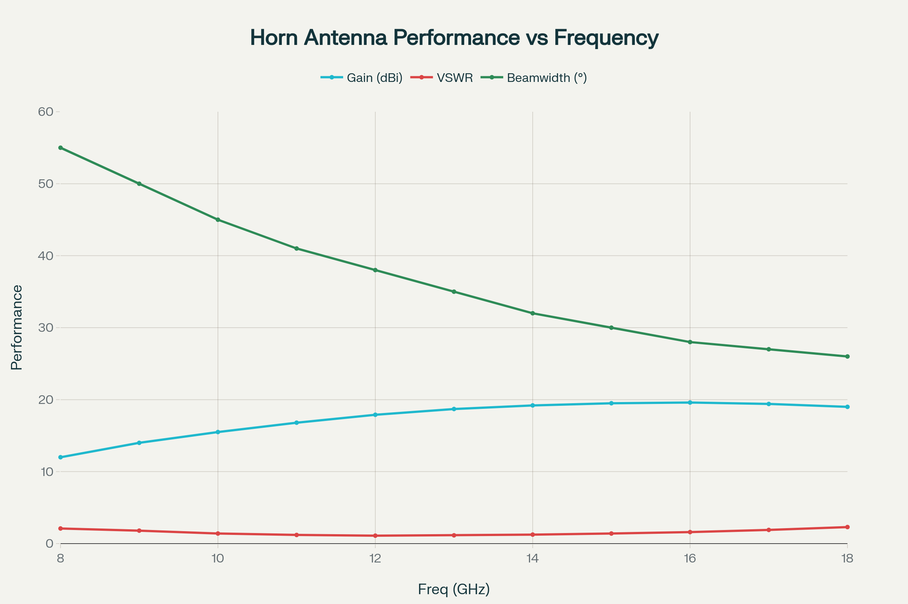

Figure 3 – Horn antenna performance characteristics across X-band frequency range showing gain, VSWR, and beamwidth variations.

**6.2 VSWR Characteristics**

The **low VSWR across wide bandwidths** makes horn antennas excellent for broadband applications. The gradual impedance transformation minimizes reflections.

**6.3 Pattern Stability**

**Radiation patterns remain stable** across the operating frequency range, making horn antennas reliable for applications requiring consistent directional characteristics.

**7. APPLICATIONS**

**7.1 Feed Horns for Reflectors**

**Horn antennas provide excellent feeds for parabolic reflector antennas**. They illuminate the reflector sufficiently evenly without too much spillage over the edge while minimizing spurious responses to off-axis signals.[4]

**7.2 Radar Systems**

**Short-range radar systems** utilize horn antennas for their directivity and wide bandwidth. Speed enforcement cameras use horn antennas to prevent other reflections from interfering with required responses.[4]

**7.3 Calibration Standards**

Horn antennas serve as **gain standards for antenna measurements**. Their predictable characteristics and wide bandwidth make them ideal for EMC and similar measurement applications.[4]

**7.4 Satellite Communications**

**Communication satellite antennas and radio telescopes** use exponential horns as feed elements due to their high-performance characteristics. These applications demand minimum internal reflections and constant impedance.[1]

**7.5 Astronomical Research**

**Radio astronomy applications** benefit from horn antennas' low noise characteristics and stable patterns. They serve as primary feed elements for large radio telescope systems.[5]

**8. DESIGN CONSIDERATIONS**

**8.1 Flare Angle Optimization**

The **flare angle determines the trade-off** between gain, beamwidth, and horn length. Smaller flare angles provide higher gain but require longer structures.

**8.2 Aperture Design**

**Aperture dimensions control directivity** and pattern characteristics. The phase error increases with aperture size, limiting practical dimensions.

**8.3 Frequency Scaling**

Horn antennas **scale proportionally with wavelength**, making them suitable only for microwave frequencies where physical dimensions remain manageable.[4]

**9. MEASUREMENT TECHNIQUES**

**9.1 Pattern Measurements**

**Radiation pattern testing** requires far-field conditions or near-field scanning techniques. Anechoic chambers provide controlled environments for accurate measurements.

**9.2 Gain Calibration**

**Gain measurements use three-antenna methods** or comparisons with standard gain horns. The predictable nature of horn antenna gain makes them excellent calibration references.

**9.3 VSWR Testing**

**Vector network analyzers characterize impedance matching** across the operating bandwidth. The wide bandwidth requires careful measurement setup and calibration.

**10. ADVANCED CONFIGURATIONS**

**10.1 Multi-Band Horns**

**Dual-band and multi-band designs** enable operation across multiple frequency ranges. These configurations require careful optimization of flare profiles.

**10.2 Polarization Control**

**Corrugated horns provide excellent polarization characteristics** with low cross-polarization levels. Septum horns can generate dual circular polarizations.

**10.3 Array Integration**

**Horn antenna arrays** provide higher gain and beam steering capabilities. Proper element spacing and feeding networks are critical for array performance.

**11. COMPARATIVE ANALYSIS**

|  |  |  |  |  |  |
| --- | --- | --- | --- | --- | --- |
| Horn Type | Bandwidth | Gain (dBi) | Cross-Pol | Applications | Complexity |
| **Pyramidal** | 10:1 | 10-20 | Moderate | General Purpose | Low |
| **Conical** | 15:1 | 12-22 | Good | Circular Waveguide | Medium |
| **Exponential** | 20:1 | 15-25 | Good | High Performance | High |
| **Corrugated** | 8:1 | 15-25 | Excellent | Feed Horns | Very High |
| **Sectoral** | 8:1 | 8-15 | Poor | Fan Beams | Low |

*Table 1: Performance comparison of horn antenna types*

**12. FUTURE DEVELOPMENTS**

**12.1 Metamaterial Integration**

**Metamaterial-enhanced horns** may achieve improved bandwidth and reduced size while maintaining performance characteristics.

**12.2 3D Printing Technology**

**Additive manufacturing** enables complex internal structures and novel horn geometries previously impossible with traditional machining.

**12.3 Reconfigurable Designs**

**Electronically variable horns** using MEMS or liquid crystal techniques could provide adaptive beam shaping and polarization control.

**13. CONCLUSION**

Horn antennas represent **fundamental building blocks** of modern microwave systems, providing reliable directional radiation with excellent bandwidth characteristics. The five major types each offer specific advantages for different applications, from simple pyramidal horns for general use to sophisticated corrugated horns for demanding satellite applications.

The **wide bandwidth, stable patterns, and predictable characteristics** make horn antennas invaluable for feed applications, calibration standards, and radar systems. While limited to microwave frequencies due to size constraints, their performance advantages ensure continued importance in telecommunications, astronomy, and measurement applications.

Future developments in **manufacturing techniques and advanced materials** will expand horn antenna capabilities while maintaining their fundamental advantages of simplicity, reliability, and excellent RF performance across wide frequency ranges.

**REFERENCES**

1. <https://en.wikipedia.org/wiki/Horn_antenna>

1. <https://rfcom.co.uk/what-are-the-different-types-of-horn-antenna/>

1. <https://www.ijert.org/research/radiation-analysis-and-design-of-pyramidal-horn-antenna-IJERTV2IS100033.pdf>

1. <https://www.electronics-notes.com/articles/antennas-propagation/horn-antenna/basics-primer.php>

1. <https://www.rf-miso.com/news/the-working-principle-and-application-of-horn-antenna/>

1. <https://www.cdeep.iitb.ac.in/slides/A16/EE609/EE609-L19.pdf>

1. <https://www.slideshare.net/slideshow/horn-antennas-167441312/167441312>

1. <https://www.antennaexperts.co/blog/microwave-antenna-types-usage-applications>

1. <https://ijcrt.org/papers/IJCRT2003265.pdf>

1. <https://www.youtube.com/watch?v=MOvVkotklfE>

1. <https://www.sannytelecom.com/9-main-horn-antenna-types-and-applications/>

1. <https://ignited.in/index.php/jasrae/article/download/10449/20701/51717>

1. <https://www.ece.mcmaster.ca/faculty/nikolova/antenna_dload/current_lectures/L18_Horns.pdf>

1. <https://www.microwavejournal.com/articles/35247-applications-considerations-for-double-ridge-guide-horn-antennas>

1. <https://www.mathworks.com/help/antenna/horn-antennas.html>

1. <https://www.elprocus.com/horn-antenna/>

1. <https://www.tutorialspoint.com/antenna_theory/antenna_theory_horn.htm>

1. <https://buzztech.in/horn-antenna-types-operation-applications/>

1. <https://www.space-machine.com/horn-antennas/>